Name :Sk.kashifa

Registration no: 192121135

Supermarket management system :

Class diagram :

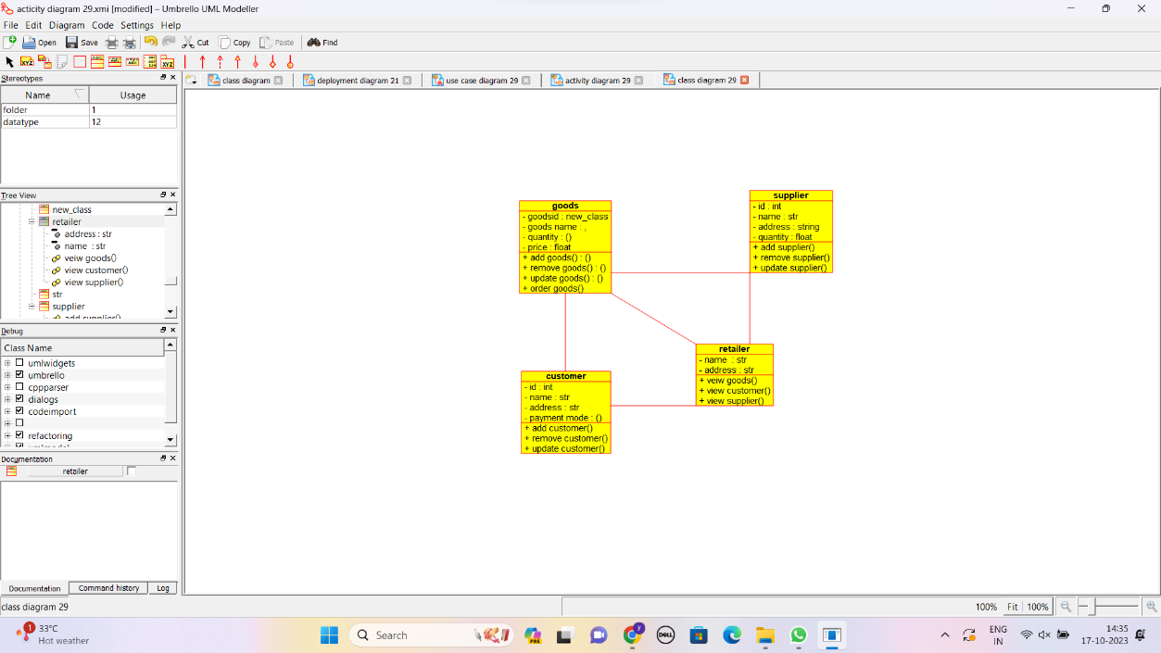

Deployment diagram :

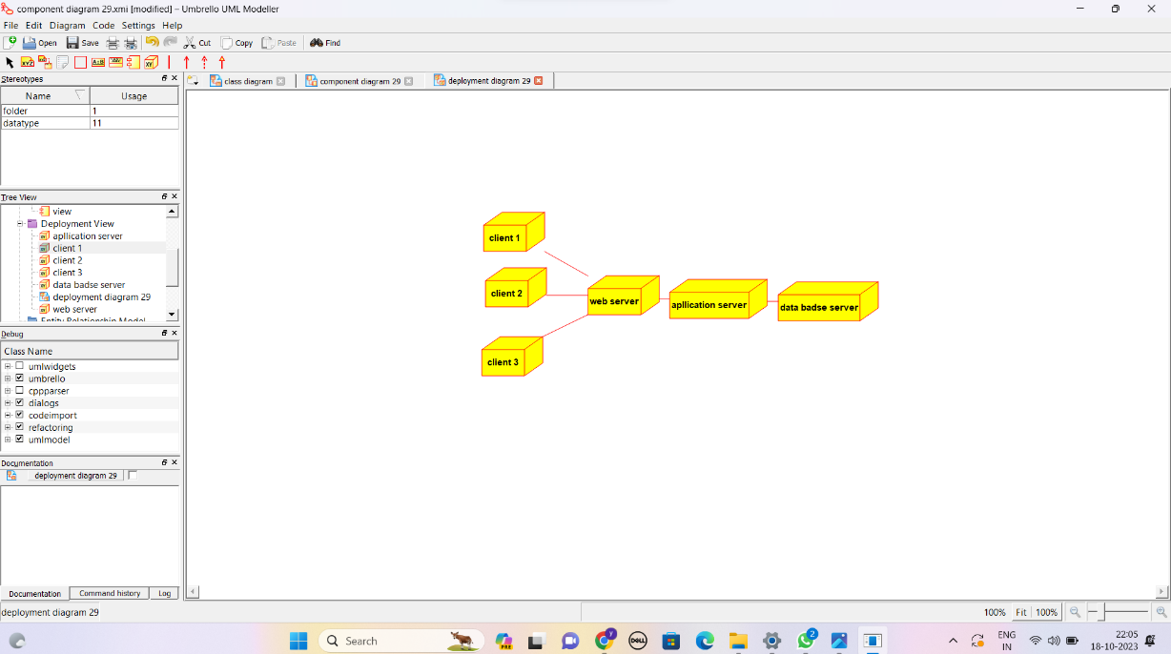

Usecase diagram :

